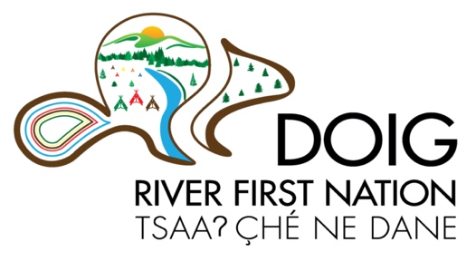
Doig River First Nation
Job Posting
Mental Wellness and Addictions Therapist
Doig River First Nation (DRFN) is seeking applications from qualified candidates for the position of Mental Wellness and Addictions Therapist.

DRFN envisions an idealized system of services where people and their families receive care and services within their homes and in the community administration offices supported by interprofessional teams. The Mental Wellness and Addictions (MHA) Therapist functions as a member of the Health and Social Development team and applies best practices to provide competent, safe, and ethical care for DRFN membership in a culturally appropriate manner.
Through assessment and involvement of each person and their family, the MHA Therapist develops and implements a plan of care and intervention to assist the person in managing their mental health or addiction challenges. The MHA therapist will provide care according to the person’s own care plan and personal goals.
Qualifications

Education

- Master’s Degree in Counselling Psychology or Social Work, plus three (3) years’ recent related experience providing care through a holistic mental health, substance use and care lens or an equivalent combination of education, training and experience.
- Current full registration with the Indigenous Certification Board of Canada (ICBOC), Canadian Certified Counsellor (CCC), BC Association of Certified Counsellors (BCACC), or BC College of Social Workers.
- Valid BC Driver’s License.

Knowledge and Experience

The ideal candidate will have a comprehensive knowledge of the following:
- Other health care disciplines and their role in client care
- Principles and practices of a client and family centered recovery model in mental illness
- Care coordination to a select caseload of clients
- Providing culturally safe and competent care, specifically pertaining to Indigenous people
- Trauma informed practice, harm reduction and recovery-oriented care that is holistic in its approach
- Crisis intervention and supportive counseling skills
- Mental health illness and treatment
- Substance abuse and addictions treatment
- Other facilities and community resources

Skills & Abilities

The preferred candidate will possess the following skills and abilities:

- Conducting mental status exams and suicide risk assessments
- Care planning, supportive counseling, crisis intervention, and case coordination
- Communications that are effective, both orally and in writing, with clients and their families, colleagues, physicians, and other health care staff, both one-on-one and in groups settings
- Listening and information seeking skills that promotes communication and lead to a cooperative approach to problem solving within a multidisciplinary setting
- Establishing workload priorities and adjust schedule to deal with unexpected situations
- Working independently and collaboratively as a member of a multidisciplinary team, providing consultation and leadership
- Problem solving and critical thinking skills to deal effectively with conflict situations.
- Managing a variety of situations and responsibilities requiring initiative, creativity and professional judgment
- Assessing clients at risk and knowledge of appropriate acts, e.g. Mental Health Act, Adult Guardianship, Public Health Act as it relates to the rights and obligations of clients and staff
- Physical ability to perform the duties of the position
- Computer literacy to operate a computerized client care information system, word processing, Internet, and email software.
- Strong understanding of traditional Dane-zaa and Doig River First Nation culture, values, interests, and history including Treaty 8 and treaty rights.

This is a full-time permanent position that offers extended health and dental benefits with flexible hours and location of service delivery.

Interested persons may submit their resume and references to:

Shona Nelson, Band Manager Doig River First Nation
Box 56, Rose Prairie, BC. V0C 2H0 Email – snelson@doigriverfn.com
Deadline for application is February 18, 2022

